SIGNS AND BARRICADING

PURPOSE
The purpose of this procedure is to outline the requirements for the standardization and effective use of HSE signs, signals, barricades and information boards of hazardous area for all workers and visitors on the project Hurlag Oil and gas development phases.

SCOPE
This procedure applies to all activities during Construction, Commissioning and Operations; used by all members of the Project Management Team, Supervisors and Contractor personnel who supervise work where effective communication is a key item in matters of HSE control. It is used to protect not only the persons working directly on the Project but also other persons in the vicinity, including visitors and members of the public.

RESPONSIBILITIES

Site Manager
Ensure that all employees understood and do comply with this safety procedure.

HSE Manager
He is responsible to:
- Ensure that Company, contractor and Subcontractors management are familiar with this procedure.
- Identifying and ordering sufficient signs and barriers to consider the areas of work safely.
- Monitor site conditions to ensure that signs and barriers are being erected as appropriate to the working conditions.
- Provision of instructions, as required.
- Ensuring that all items of commissioned and live plant are clearly indicated.
- Ensuring that all employees receive appropriate information, instruction and training regarding safety signs. Although most signs are self-explanatory, some employees (particularly young or new workers) may be unfamiliar with the signs used.
- Ensuring that all signs are being prepared in languages which personnel are familiar with. In multinational projects, the signs must be prepared in several languages, English, local language and any language which the personnel can notice
Supervisors / Superintendents Will be responsible for:
- Identifying and ordering sufficient signs and barriers to consider their areas of work safely.
- Ensuring that signs and barriers are erected in accordance with this procedure.
- Ensuring that adequate barriers are provided around areas where hazards may exist.
- Ensuring that all items of commissioned and live plant are clearly indicated.
All Contractors
Will be responsible for:
- Prepare sufficient signs or barricades in accordance with HSE requirements.
- Monitor site conditions to ensure that signs and barriers are being erected as appropriate to the working conditions.
- Ensuring that signs and barriers are erected in accordance with this procedure.
- Ensuring that all employees receive appropriate information, instruction and training regarding safety signs.
- Ensuring that all signs and barricades are being kept in suitable situation and repair or replace them if required
- Ensuring that all signs are being prepared in languages which personnel are familiar with. If foreign employee are in subcontractor, the signs must be prepared in several languages, English, local language and any language which the personnel can notice

PROCEDURE:
The signs depicted in this procedure can be grouped as follows:
- Prohibition
- Mandatory
- Warning
- Emergency Escape and First aid Signs
- Fire Fighting Signs.

General
- The standardization of HSE signs throughout the Project is necessary so that wherever a particular HSE sign is seen it provides the same warning or information message to all persons.
- This is an essential factor in HSE communication, especially on Projects where a multinational workforce is employed.
- HSE signs are not a substitute for those other methods of controlling risks such as engineering control and safe systems of work.
- To determine when and where to use HSE signs, members of the Project Management Team must take into account the results of Risk Assessments carried out that deal with identification of hazards and the risks associated with them.
- These instructions shall apply equally to office, workshop, site or other location used by company, Contractor or subcontractors during the course of the project.
- All emergency exits passageways, fire extinguishers and boxes, first aid stations, eye wash stations, emergency muster points shall be highlighted with safety condition signs.
- Warning signs shall be erected and displayed for fire hazards, electrical equipment, openings, overhead working, noisy areas, and other hazards...
- Mandatory signs shall be provided for enforcing the use of personal protective clothing and equipment and providing specific instructions appropriate to the task or condition. Prohibition signs will be displayed for restricting access or entry, no smoking areas, no parking, and any other unauthorized acts.
- Fire signs shall be provided at areas where fire equipment has been sited e.g. fire extinguishers, fire points, fire blankets, etc.
- Barriers and warning tape will be provided as appropriate, only fixed and solid barriers will be used for edge protection on excavations, floor openings and penetrations.

Specifications
The following specifications shall be followed when ordering signs.
Prohibition Signs: Round Shape - Background colour shall be white with black symbol, centrally placed and red circular band and crossbar. A minimum of 35% of the sign shall be red.
Mandatory: Round Shape - Background colour shall be blue, with a white symbol or text centrally placed. At least 50% of the sign shall be in blue.
Warning: Triangular Shape - Background colour shall be yellow with a triangular warning symbol edged with a black band. The text or symbol will be in black and centrally located. At least 50% of the sign shall be in yellow.
Emergency Escape and First Aid Signs. : Rectangular or Square Shape - Background colour shall be green with white symbol or text. At least 50% of the sign shall be in green.
Fire Fighting Signs: Rectangular or Square Shape - Background colour shall be red with white symbol or text. The shape of the sign shall be square or oblong. At least 50% of the Sign shall be in red.
Use of HSE Signs
- The use of HSE signs requires careful planning; they are only effective if they can be seen and understood e.g. a sign denoting the position of a stretcher needs to show clearly where the equipment is.
- If too many signs are placed together there is a danger of confusion resulting in important information being overlooked.
- It is essential that when circumstances change and the hazards no longer exist, that signs are removed to prevent misleading information being displayed.
- Signs must be durable, securely fixed, properly maintained and cleaned on a regular basis to ensure they remain visible at all times.
- Lighting will have to be provided if applicable to illuminate the signs during conditions of poor natural light and where required, signs will need to be manufactured from reflective material.
- There are 4 basic types of Safety Signs used in projects Worksites: These are:

- Must do
- Must not do
- Caution
- Safety

Safety signs remind us of things that we should do to ensure our Safety or the Safety of others. Safety signs have three features that give us information quickly and without confusion:

COLOURS
Should tell us what type of message a sign has for us.
Red signs mean either:
- Stop doing something or don’t do it (prohibition);
- Stop / shutdown or evacuate;
Or they mark the location and type of fire-fighting equipment.
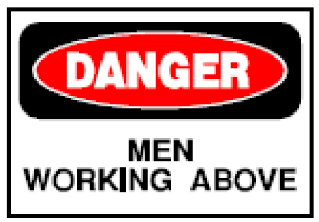
The symbol for the prohibited action should be shown in black behind the red diagonal bar: for example, 'No Smoking' with a cigarette depicted.
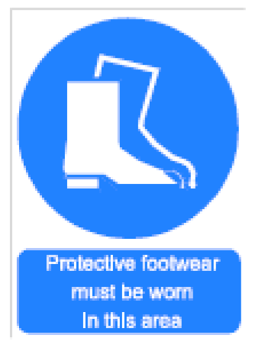
A sign indicating fire-fighting equipment is a red square or triangle, with information given in words or by symbol in white.
Yellow signs are advisory and mean:
- Be careful, or take precautions
The symbol for the hazard is depicted in black: for example, poisoning risk with black skull and crossed bones on the yellow background.

Blue signs are mandatory and mean:
Take specific action
Mandatory signs are based on a blue disc. The symbol for the precaution to be taken is shown in white: for example, 'Goggles to be Worn' with a man's head with goggles depicted. If, exceptionally, no suitable symbol is available, appropriate wording may be used instead: for example, 'Keep Clear'.

Green signs mean:
- Emergency escape; or
- First aid sign
The sign is a green square or rectangle, with safety information shown by words or a symbol in white: for example, a white arrow on a green background points to an emergency exit. The same principle applies to fire-fighting equipment.
If there is need to amplify or clarify the meaning of any symbols used in a safety sign or notice, then a supplementary sign with text only (for example, 'Not Drinking Water') should be given below the sign.

PICTOGRAMS
Colours and shapes should tell us beware - do this, or don't do that. Pictograms of “Burning Cigarettes, “Danger Overhead Crane”, PPE requirements, and so on, tell us what the sign is about.

Functional Groups
Safety signs are classed by function into groups.

Regulatory Signs
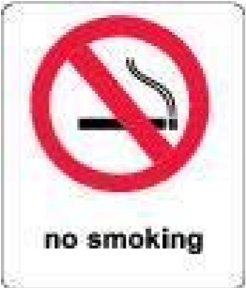

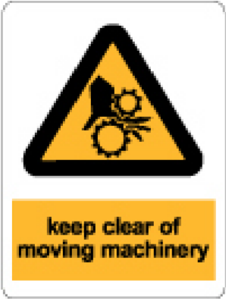
These signs contain instructions where failure to comply constitutes an offence under law. Mandatory and Prohibition Signs are the most commonly used regulatory signs.

- Mandatory Signs direct an action that needs to be carried out to work safely.

- Prohibition Signs indicate an action or activity is forbidden, depicted by the symbol or text.

Hazard Signs
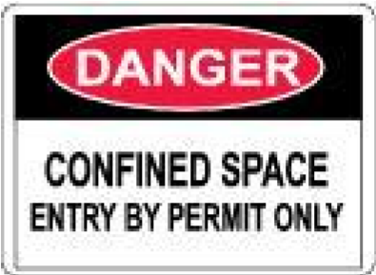
These warn of hazards or hazardous conditions. Warning and Danger signs warn of hazards according to the severity of the threat.

- Warning signs alert the reader to hazards that are not life-threatening.

- Danger signs warn of life-threatening hazards or hazardous conditions.

Fire Safety Signs
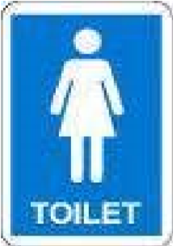

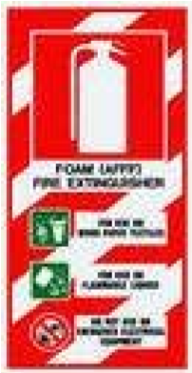
Fire Safety signs show the location of fire fighting equipment & alarms and give instruction.

Emergency Information Signs
These signs indicate the location or direction of emergency related facilities such as emergency showers or basins.

General Information Signs
General Information signs provide instructions for safe work practices, locations of offices, toilets, etc. as well as safety equipment and reminders for correct safety procedures or general work procedures.
Sizes and Positioning of HSE Signs
Where signs are used they must be sufficiently large and affixed in areas where they are not obstructed.
The actual size and positioning of signs must be undertaken at the discretion of the site HSE Officer.

The location of signs:
- Must be in visible location where everybody can see it.
- Must be in safe location which doesn’t make any risk for workers.
- If it will be possible out of direct sunshine to preventing any destroy.
- Be in location with suitable luminance without any severe shade.
- Mustn’t be covered by any objects such as trees or so on.
- Doesn’t obstruct the road or accesses or makes problem for transportation. Must has enough space for installing of signs

The size of sign boards:
Suitable for being seen regarding the distance and location (from 20 meters). Suitable from point of high, wide and spaces between letters or images.

HAND SIGN
- Hand signs are an ideal communication tool when working around noisy industrial machinery. Many times the noise is so load it is impossible to hear even if everyone is yelling. The hand signs provide a way to communicate the needed information effectively. Hand Signals must be precise, easy to make and understand. They must be clearly distinct from other signals.
- Where both arms are used at the same time, they must be moved symmetrically and used for giving one sign only.
- The person giving the signals must be able to monitor all the manoeuvres visually without being endangered by it.
- If the person giving the signals cannot monitor all the manoeuvres visually or the operator cannot see the signalman at all times then one or more additional signal men will need to be provided.
- The signalman's duty must consist exclusively of directing manoeuvres and ensuring the safety of other persons in the vicinity.
- The operator must stop any manoeuvres if he cannot see the signalman or men and when he is unable to carry out the orders received in a safe manner.
- The operator must be able to easily identify the signalman or men.
- The signalman or men must wear distinctive items e.g. a reflective jacket of a different colour to other persons working in the area, or a Safety Helmet of a different colour, or Reflective sleeves or armbands.
- Signalmen and Operators must be trained in the recognition of correct signal techniques.
- It is prudent to allow the Signalman or men and the Operator to spend some time together to fully understand signalling techniques prior to manoeuvres being carried out, especially if they are new to each other.

Site Perimeter and Access Point Signs
Where practicable, fencing and signs will be erected to contain construction areas with the following signs:
- Authorized personnel only( English and local language)
- Hard hats to be worn.
- Eye protection required.
- Safety footwear.
- Speed Limit 10 Km/Hr.

Precautions and Considerations
- Signs may only be installed with the approval of the relevant unit or department manager and HSE supervisor
- An audit of signs should to be undertaken on a 3 month interval basis.
- Each Unit/Department is to have adequate notice-board space

Barrier and Bunting tape
Objective
Safety Barriers are one of the risk control measures required to protect people exposed to dangers of, for example:
- Being struck by falling objects, moving material or plant
- Falling into, though, or off, open excavations, holes, openings and elevated platforms
- Exposure to hazardous substances, process or activities.
Effective use of and compliance with safety barriers will isolate and reduce the risk of exposure to hazards. Task planning and execution has to include the effective use of barricading combined with procedural and behavioural methods of safety risk control. The standard of barricading used must always be appropriate to the level of risk and must always be consistently applied.
This procedure aims to explain the best method of barricading and safe guarding the dangerous locations or/and activities from people or/and vehicles.

General
Those persons erecting bunting(s), barricade(s) or temporary fencing must, prior to erection, review and assess the hazards associated with the proposed work, the placement of the bunting or barricade, adjacent work areas and other factors that may impact on the type of bunting or barricade. They must also assess its location, materials used to construct the bunting or barricade and any other factor that will impact on the safety of those working in the barricaded area or adjacent areas.

Use of barricade
Types of barricade used at the projects in Hurlag include: nylon rope, wire rope, guardrails, plastic tape (Danger and Caution), and orange grid netting. All barricades shall be accompanied by an accident prevention tag or sign (Caution, Warning, or Danger) to alert associates of the hazard that exist and the person to contact if entry to the barricaded area is required.
As a rule, barricades should not be crossed unless permission has been obtained by the individual(s) responsible for the barricades. Portable barricade must be strong enough and when necessary provided with additional stabilization to prevent movement if a person accidentally fall against it. At the edge of high elevation such as roads, use of strong and fixed barricades is necessary to prevent movement of them if a car accidentally impacts them.
Barrier tape shall be suitable for external use and maybe either;
- Fluorescent, orange or other high visibility colour (for traffic control).
- Red and white or yellow and black for general warning.
- Hazard warning pennants.
Fixed barriers either constructed from scaffolding or timber shall be used for the areas such as excavations below 1.2 meters in depth or floor openings/penetrations where persons may fall or the perimeters of the sloppy areas.

Portable Barricades
Portable barricades must be strong enough and when necessary provided with additional stabilization to prevent movement if a person accidentally fall against it.
Portable barricades and signs should also be secured to prevent them from being blown over during high winds.
This is essential when barricades and signs are used to denote detours on site roads and public roads.
Type of barricading
There are three types of barricades allowable;
A ) Danger Barricade using Red & White bunting tape requiring no unauthorized entry ;
This type of barricade tape indicates DANGER and that a potential serious hazard may be present. No employee, other than the craft assigned to work inside a RED barricade, may enter without first obtaining permission from the erector of the tape. This barricade tape is used for, but is not limited to, the following:
- Overhead work
- Live electrical components
- Scaffold under construction
- Around swing radius of equipment with a rotating superstructure.
Danger Barricade with Danger Tape shall be used for two primary functions:
- To restrict access to a defined area containing hazards and risks, e.g. a hole in the ground, overhead work is being conducted from which an object may fall, construction and building areas, earthworks involving mobile and other moving equipment; etc.
- To provide protection to those personnel working within the defined area from unauthorized access by any other person or activity.
- Each Danger Barricade shall have a warning or information Tag attached to a Danger barricade to identify the purpose, owner and duration of requirement for the barricade. (Including when the Danger Barricade is used in conjunction with a Group Isolation)
- The rules for the use of Warning or Information Tags shall apply.
- If the barricade is going to be within 600 mm from a hole or potential to fall, then a fixed barricade (handrail) will be required.
Caution Barricade using Yellow and Black bunting tape requiring persons to stop, look, think, and then proceed with caution if safe to do so.
This type of barricade tape serves as a caution to indicate to employees of a potential hazard. Employees may enter without permission from erector of this tape. This barricade tape is primarily used for the following:
- Excavation less than 1.2 meters (4 feet) in depth
- Identification of tripping hazards and low hanging objects - Material storage on the site.
Caution Barricade with Caution tape can be used for purposes other than unauthorized entry requirements such as bringing attention to hazards, temporary separation of pedestrian ways and roadways, etc.
Commissioning Control Barricade using rope with Blue & White flag bunting for identification of commissioning area.
Commissioning Control Barricade with rope and flagging shall be used for demarcating and controlling access areas for commissioning activities.

Magenta (Purple) Yellow Tape
This type of barricade tape is used to indicate DANGER—RADIATION and that possible exposure may be present. This barricade tape is considered to be as an equal to red in that no employees are allowed to enter this area without first obtaining permission from the erector of the tape. This colour is representative of x-ray work being performed.

Pre-Job Preparation (when job is going to proceed) Supervisors and managers:
- Determine the safety hazards that are associated with or created by the planned work activities, e.g., open trenches, uneven walking surfaces, potential flying chips, parts, sparks.
- Contact the painting shop and request the proper safety signs to demarcate the identified safety hazards or prepare related and suitable signs from other sources.
- Ensure signage is located at the area tool cribs for back shift access.
While Working
Supervisors and managers:
- Establish appropriate barricades and signage around identified safety hazards or work activities requiring personal protective equipment.
- Place signage on all barricades that identify the hazards.
- Reassess the work area and, if necessary, obtain and post additional signs and/or establish additional barricades when conditions change or new safety hazards are identified.
- Prevent unauthorized personnel from entering barricaded areas.
- Ensure that signs and barricades are promptly removed or covered when a hazard no longer exists.
- Ensure construction areas are barricaded and posted "Construction Area," with a physical boundary (such as rope or fencing, where practical) to control access and warn of potential hazards.
- Cover floor openings and label them "Hole Covering-Do Not Remove" secure floor openings to prevent movement.
- Ensure any bridging has load limit markings posted

Disciplinary Action

Disciplinary action in respect to the preceding procedures will be as per the following criteria.

Removal from Site or Dismissal

Offences that will lead to an employee, contractor, or contractor’s employee being liable for removal form site or dismissal are:
- Energizing and/or operating equipment that has a Personal Lock, an Equipment
Lock, or contrary to the conditions stated on the Warning Tag
- Working on equipment that has not been isolated and locked
- Entering into a Danger Barricade area without authorization from the barricade owner.

Offences that will lead to contractor employee, contractor, or contractor’s employee being liable for disciplinary action are:
- Removing another person's Warning Tag without authority to do so
- Failure to remove one’s own Warning Tag at the completion of the job or at the end of the shift, when it is required
- Any other breach of procedure.

General project Sign
Erect project sign at the main entrance to the construction site and other sites, i.e., office, laydown yard, fabrication yard, etc., as designated by the Company representative.
The printing on the sign shall be black and white.
The sign shall list as minimum:
- PROJECT MANAGEMENT ORGANIZATION
- PROJECT TITLE
- PRIME CONTRACTOR NAME, ADDRESS, AND TELEPHONE NUMBER
- HOUR EMERGENCY PHONE NUMBERS FOR COMPANY REPRESENTATIVE AND CONTRACTOR
- TOTAL WORKING MAN HOUR OF PROJECT
- LOST TIME DAYS OF THE PROJECT
- TOTAL WORKING MAN HOUR OF PROJECT AFTER LAST LOST TIME DAY (LTD) ACCIDENTS

The sign shall be erected within two weeks after the contractor has started work on site. Contractor shall also erect and maintain sufficient signs on or near the site to direct delivery vehicles and visitors to the work site.

Information, Instruction and Training
- All persons working on Projects must be made aware of and understand the meaning of HSE Signs and signals that they come into contact with, during their working activities.
- It is particularly important that the meaning of any new or unfamiliar sign is clearly explained.
- Where necessary, standard signs may have to have a form of translation into the relevant language used by the majority of persons working on the project.
- All persons must be made aware of the consequences if they do not follow the warning or instruction given by the sign.

Definition & Abbreviation WHAT IS A SAFETY SIGN?
A safety and/or health sign is ‘information or instruction about health and safety at work on a signboard, a colour, an illuminated sign or acoustic signal, a verbal communication or hand signal.’ These terms are all detailed in guidance to the regulations. A signboard is a combination of shape, colour and symbol or pictogram made visible by adequate lighting and which may have supplementary text. Signboards, including fire safety signs, are designed as follows:

APPENDIX : Prohibitory Signs

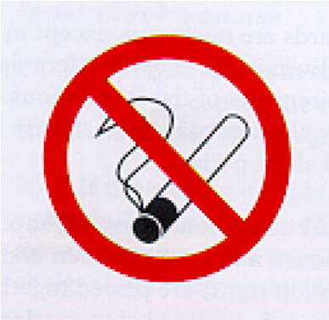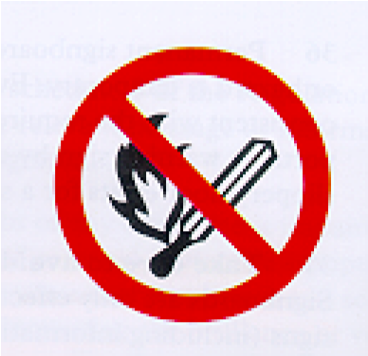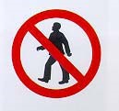
No Smoking. | Smoking and naked flames forbidden. | No access for pedestrians
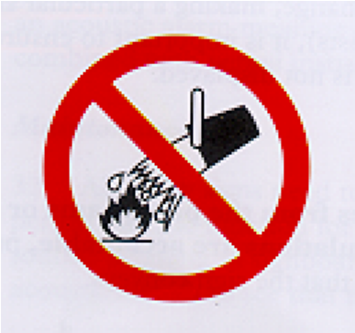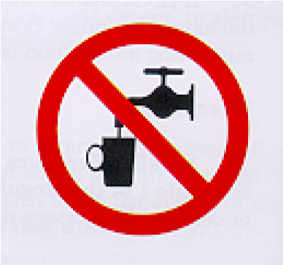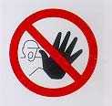
Do not extinguish with water. | Not drinkable | No access for  Unauthorized persons
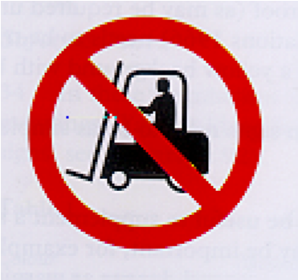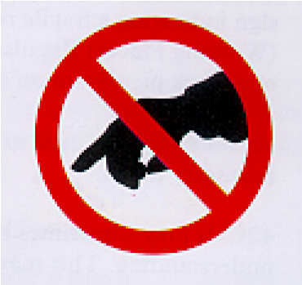
No access for
Do not touch
Industrial vehicles

APPENDIX : Mandatory Signs



Eye protection must be worn

Respiratory equipment must



Safety helmet must be worn

Safety boots must be worn

Ear protection must be worn

Safety gloves must be worn
be worn.

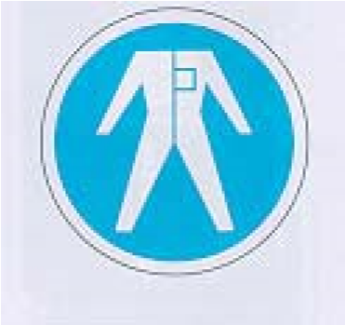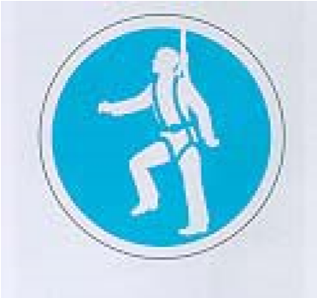
Safety overalls must be worn | Face protection must be  Worn | Safety harness must be  Worn

Pedestrian must use this route | General mandatory sign(to be accompanied where necessary by another sign)

APPENDIX -Warning Signs
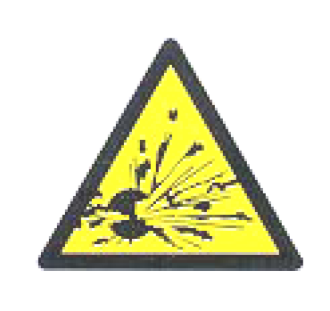
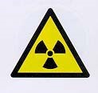
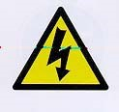
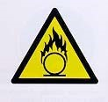
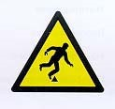
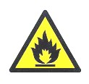

Explosive material.

Radioactive material

Danger: electricity

Oxidant material

Flammable material or high
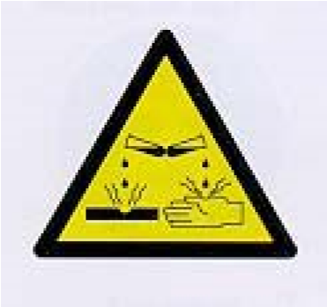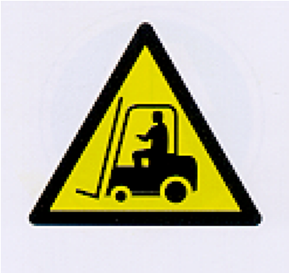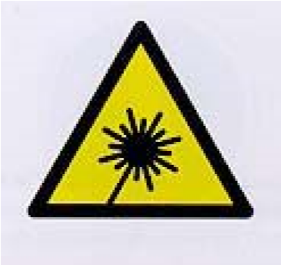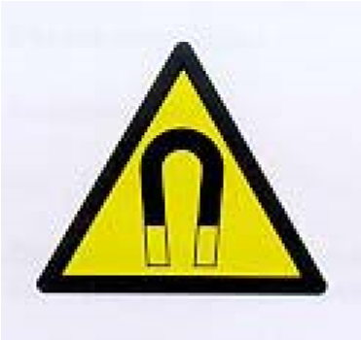
temperature

Corrosive material

Industrial vehicles

Laser beam

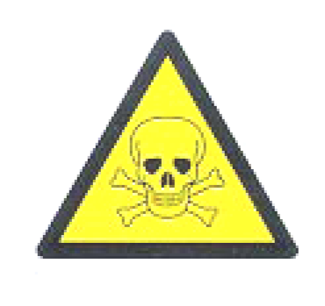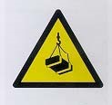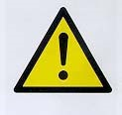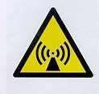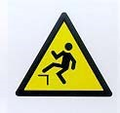

Toxic material.

Overhead load

General danger.

Non-ionizing radiation

Drop

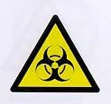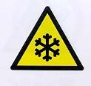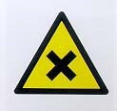
Biological risk(s) Low temperature Harmful or irritant material

Strong magnetic field Obstacles

APPENDIX -Emergency Escape Route Signs

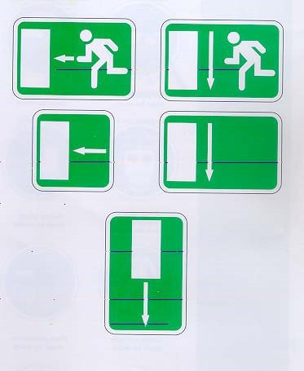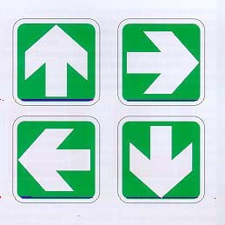

APPENDIX -First-aid Signs

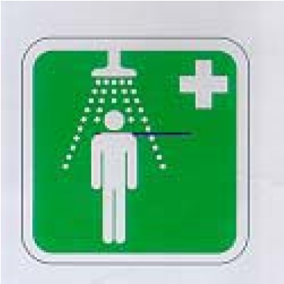
Safety Shower.

APPENDIX - Fire-fighting Signs

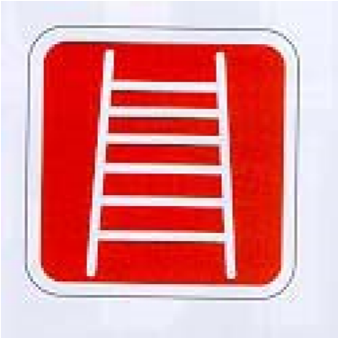
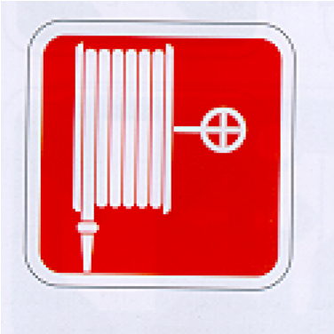
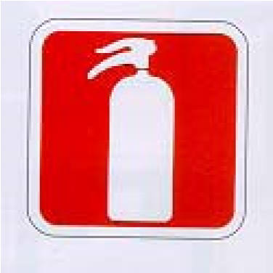
Emergency fire

Fire hose.

Ladder
telephone

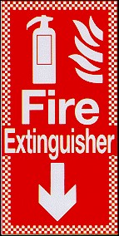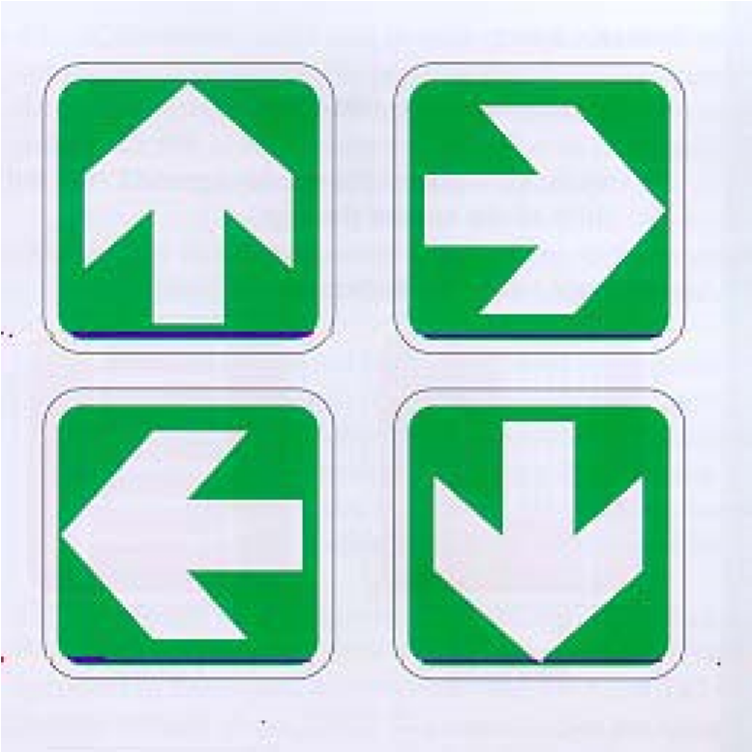
Fire extinguisher 'This way' signs for fire-fighting equipment

APPENDIX - DANGER TAPE

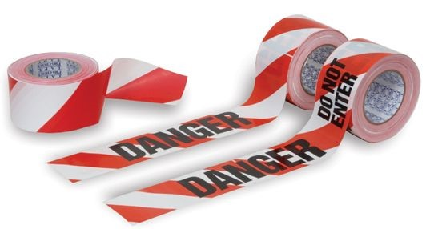

APPENDIX - CAUTION TAPE

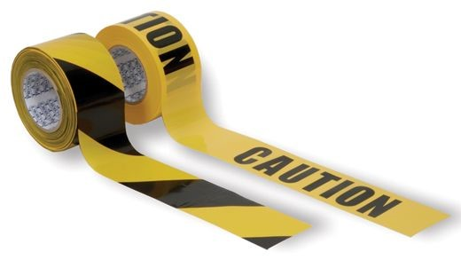

APPENDIX -COMMISSIONING CONTROL ROPE & FLAGGING



APPENDIX – DANGER TAG

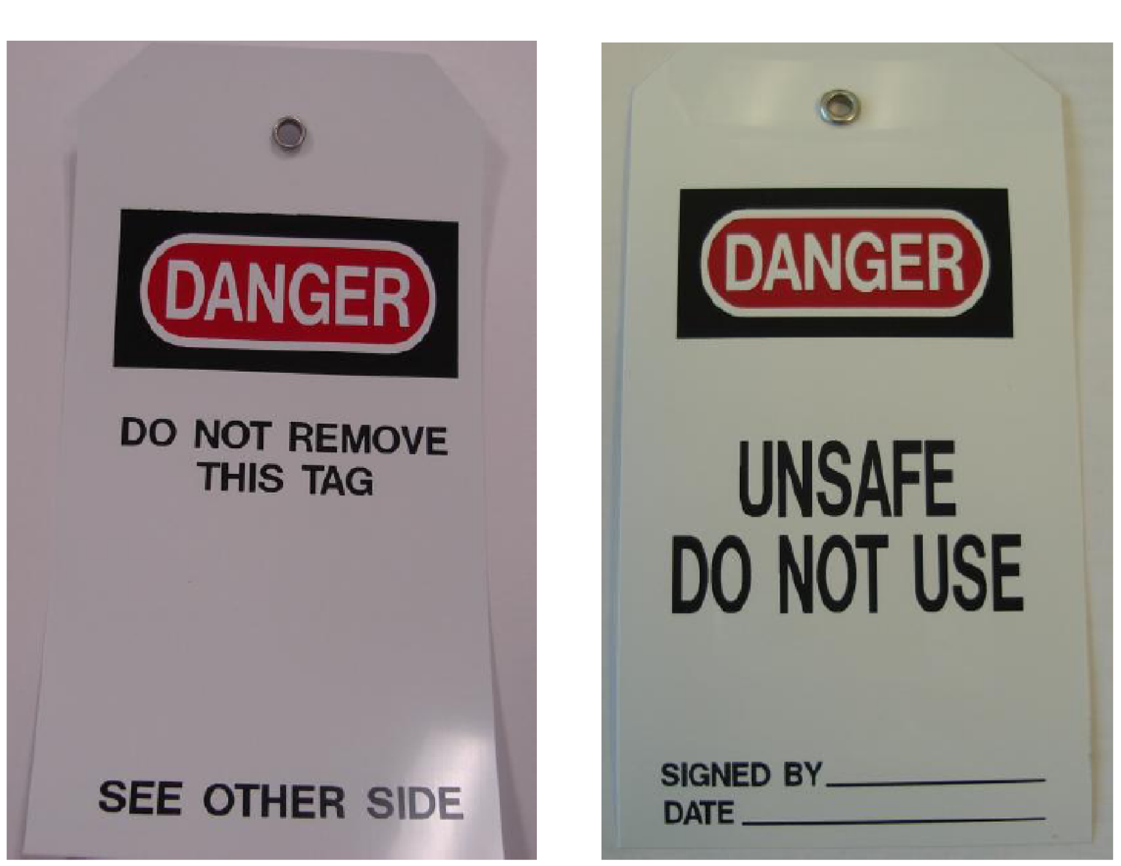

APPENDIX - General Signals.
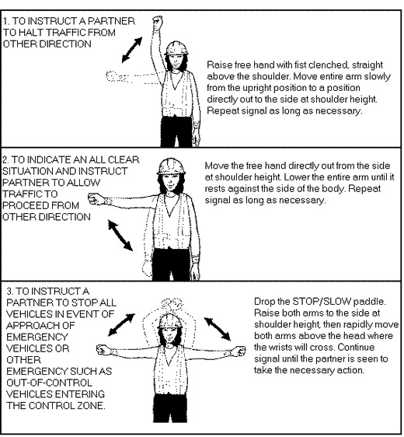

APPENDIX - HSE SIGNS CHECKLIST:

NO | DESCRIPTION | RESULT
1 | Have you identified any significant risks to health and safety that have not been avoided or controlled by means other than safety signs? | YES NO
2 | Will the use of a safety sign help reduce the risks identified in (1) above? | YES NO
3 | Are road traffic signs necessary to regulate road traffic in your workplace? | YES NO
4 | Is there a pipe work containing dangerous substance in your premises? | YES NO
5 | Have you identified any dangerous locations or traffic routes that require signage? | YES NO
6 | Have you confirmed the number, location, design and operation (if appropriate) of safety signs for your premises? | YES NO
7 | Have you sought the advice of the fire authority in relation to fire safety signs? | YES NO
8 | Have you established a system for informing, instructing and training staff regarding safety signs? | YES NO
9 | Have you established a maintenance procedure for all safety signs? | YES NO

Rev. | Date | Nature of Changes | Approved By
HTL-PR-HS-23 Vs. 1 | 02/03/2016 | Original issue. | Engr. Kamar Olawuyi Operations Director

